

THE UNIVERSITY OF AZAD JAMMU AND KASHMIR, MUZAFFARABAD
Department of Software Engineering

Submitted to: | Engr. Sidra Rafique
Course Title: | Data Structure and Algorithm
Course Code: | CS-2101
Session: | 2024-2028
Lab No: | 07
Roll No: | 2024-SE-15
Submitted By: | Shahzad Ahmed Awan
Submission date: | January 8, 2026
Table of Contents
Lab 07 – Stack Implementation 3
1. Objective 3
2. Background 3
3. Stack Using Array 3
3.1 Algorithm 3
3.2 Functions code when array implementation (file attached) 4
4. Stack Using Linked List 5
4.2 Functions when using LinkedList implementation 5
5. Conclusion 7

Table of Figures
Figure 1: Push function in Array implementation of stack 4
Figure 2:: Pop function in Array implementation of stack 4
Figure 3: Peek function in Array implementation of stack 4
Figure 4 : Push function in Array implementation of stack 5
Figure 5:: Push function in LinkedList implementation of stack 5
Figure 6: Pop function in LinkedList implementation of stack 6
Figure 7: Peek function in LinkedList implementation of stack 6
Figure 8: Display function in LinkedList implementation of stack 6

Lab 07 – Stack Implementation

1. Objective
To implement Stack data structure using:
- Array
- Linked List
Perform basic stack operations (push, pop, peek, display) demonstrating the LIFO principle.

2. Background
- Stack is a LIFO (Last-In-First-Out) data structure.
- Array-based stack has a fixed size.
- Linked list-based stack is dynamic in size.

3. Stack Using Array

3.1 Algorithm
- Initialize an array and a top pointer.
- Push elements at top, pop from top.
- Peek to view top element without removing.
- Display elements from top to bottom.

3.2 Functions code when array implementation (file attached)
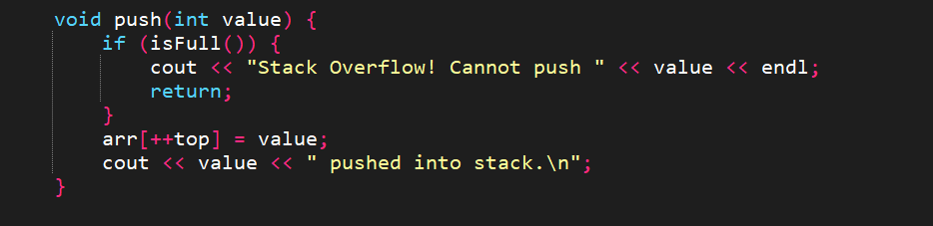
- Push Function – Adds an element at the top of the stack.
Figure 1: Push function in Array implementation of stack
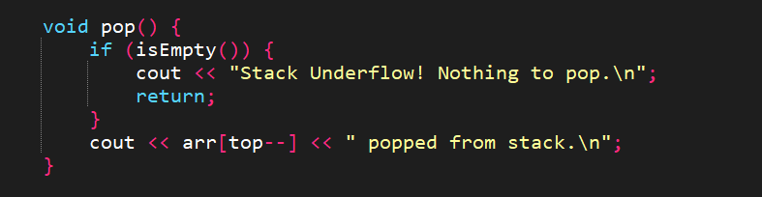
- Pop Function – Removes the top element from the stack.
Figure 2:: Pop function in Array implementation of stack
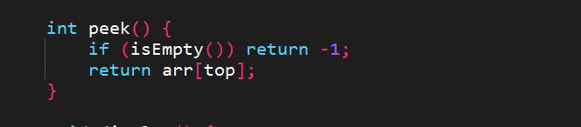
- Peek Function – Returns the top element without removing it.
Figure 3: Peek function in Array implementation of stack
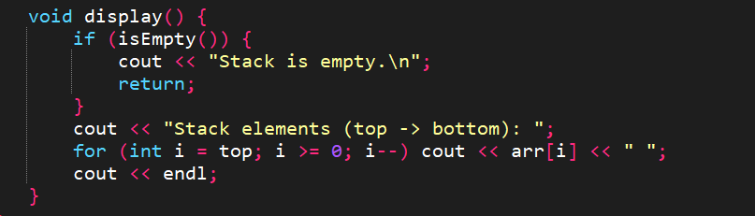
- Display Function – Displays all elements from top to bottom.
Figure 4 : Push function in Array implementation of stack

4. Stack Using Linked List

4.1 Algorithm
- Initialize top pointer as nullptr.
- Push elements by creating a new node at top.
- Pop elements by removing the top node.
- Peek to view top element.
- Display elements from top to bottom.

4.2 Functions when using LinkedList implementation
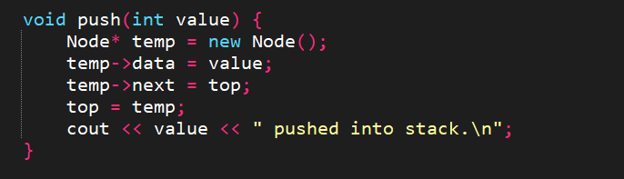
- Push Function – Adds an element at the top of the stack.
Figure 5:: Push function in LinkedList implementation of stack
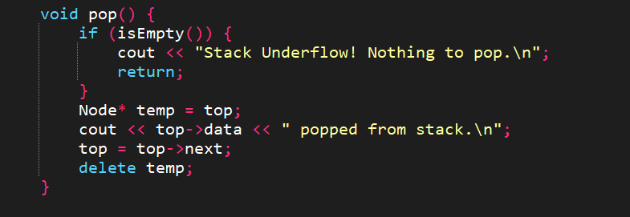
- Pop Function – Removes the top element from the stack.
Figure 6: Pop function in LinkedList implementation of stack
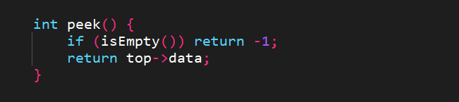
- Peek Function – Returns the top element without removing it.
Figure 7: Peek function in LinkedList implementation of stack
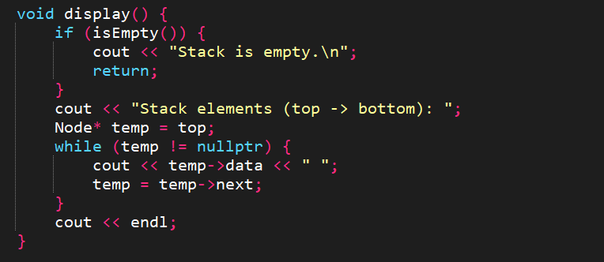
- Display Function – Displays all elements from top to bottom.
Figure 8: Display function in LinkedList implementation of stack

5. Conclusion
- Successfully implemented stack using Array and Linked List.
- Demonstrated LIFO principle and dynamic/static stack behavior.
- Stack operations are working correctly with proper interactive output.

